// Write a Program To Display Number Is Palindrone Or Not.

using System;

using System.Collections.Generic;

using System.Linq;

using System.Text;

using System.Threading.Tasks;

namespace Palindrome_Or_Not

{

class Program

{

static void Main(string[] args)

{

int N, Rev = 0, R, N1;

Console.WriteLine("Enter Any Number");

N = Convert.ToInt32(Console.ReadLine());

N1 = N;

while (N > 0)

{

R = N % 10;

Rev = Rev * 10 + R;

N = N / 10;

}

if (N1 == Rev)

{

Console.WriteLine("Number Is Palindrome");

}

else

{

Console.WriteLine("Number Is Not Palindrome");

}

Console.ReadKey();

}

}

}

Output :-

No Is Not Palindrome .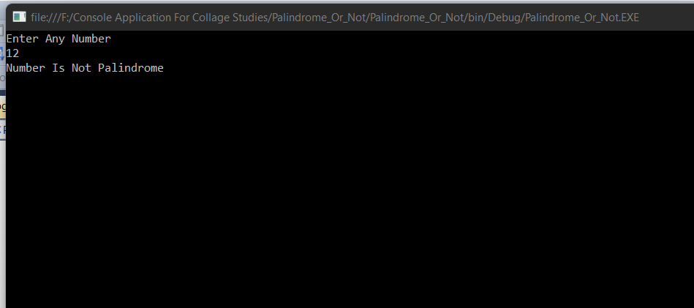

No Is Palindrome.

